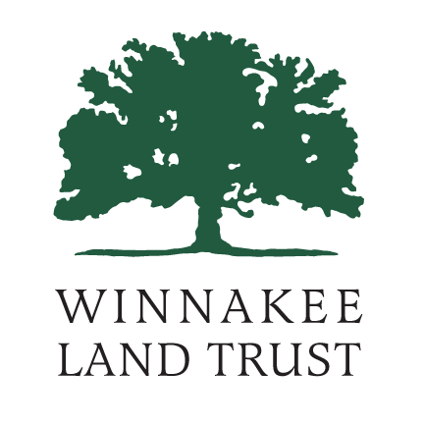
What Value Would a Trail Committee in Dutchess County Offer?

WHO ARE OUR TRAIL COMMITTEE CONSTITUENTS?
- Trail Operators
- Trail Communities
- Trail Landowners
- Trail Users

TRAIL OPERATORS, LANDOWNERS AND COMMUNITIES
- Private
- Not for Profits
- Institutions (Bard College, Marist College, Culinary Institute, Unification Theological Seminary…)
- Local Governments
- County
- State
- Federal
- Greenway
- NY-NJ Trail Conference
- Appalachian Trail Conference

TRAIL USERS
- Hikers
- Cyclists
- Pedestrians
- Commuters (School Kids, etc.)
- Equestrian
- XC Ski
- Limited transportation access (low income, non-drivers, etc.)
- Birders
- Nature enthusiasts

WHAT DO CONSTITUENTS NEED?
- Mapping
- Promotion and branding
- Wayfinding and signage
- Event partnerships
- Funding support
- Advocacy
- Access to information and expertise
- Forum to study and debate issues
- Legal advice
- Stewardship
- Assistance with building connections to existing and planned trails and destinations
- Clarity around a County-wide trail concept

WHAT CAN A TRAIL COMMITTEE PROVIDE?
- Lead a County-wide trails visioning, planning, and implementation process
- Support emerging trails and groups
- Communicate trail connection ideas and trail needs to constituents, key stakeholders, elected officials and department heads
- Assist municipalities/landowners with acquisition and/or easement logistics
- Write letters of support for grant applications
- Provide education about and support for trails resolutions
- Provide a forum to study and debate issues
- Oversee trail data collection, documentation and updates
- Create guidelines for consistent signage, wayfinding, maps, branding, and trail amenities
- Act as a clearinghouse for knowledge and sharing of stakeholder experience: best practices, sample easements, liability information, case studies, lessons learned, trail committee enabling legislation, trail-based zoning regulations, etc.
- Coordinate with neighboring Counties to maximize cross-border connections and promotion opportunities
- Increase visibility of trails and trail initiatives

WHO WOULD SIT ON THE COMMITTEE AND/OR PARTICIPATE?
- County: legislators; GIS, planning, DPW staff
- State: NYS DOT, NYS OPRHP…
- Federal: National Parks Service…
- Citizens: trail community, hiking and biking community, historical community, mobility impaired community…
- Land Trusts and Trail Management Entities
- Local Government Representatives

GOALS, GUIDING PRINCIPLES, or MISSION STATEMENT…
- Support growth of robust county-wide trails system
- Aid in establishing trails (for all the associated benefits)
- Identify and promote connections
- Identify funding opportunities and support applications
- Serve as an information clearinghouse
- Coordinate among trail stakeholders – including between state, county, and local gov AND other trail operators, constituents and users

Now that we know who the committee is, and what it does, what is the most effective parent organization for it?

